STATEMENT OF ORIGINALITY AND AGREEMENT
I/We hereby certify that my/our manuscript entitled:
STUDI PERBANDINGAN EFEK DIURETIK DAN ANTIINFLAMASI GABUNGAN
EKSTRAK SIDAGURI, TEMPUYUNG DAN SELEDRI PADA TIKUS
is an original work of my/our own, except where indicated by referencing and does not involved plagiarism. This manuscript is completely
- has not been published yet in any other publication,
- has not been reviewed by the other publisher,
- has not been sent to the other publisher,
- will not be submitted to the other publishers during the review process,
- the earlier version of the manuscript has been presented in a conference*:

has not been published yet in any other publication,

*) please ignore if never presented.
I/We patiently wait and follow the review process and will not for any reason withdraw the manuscript until final decision; rejected or accepted for publication. If not I/We will be suit and accept any sanction until banned forever from Fitofarmaka: Jurnal Ilmiah Farmasi.

Date: .10/05/2021
Name of authors’ correspondence: .Min rahminiwati
Signature

Name and Affiliation | Signature
First author: Theodorus Rexa Handoyo Affiliation: Faculty of Pharmacy, Universitas Sanata Dharma  E-mail address: rexahandoyo@gmail.com Phone: 081329121347 | 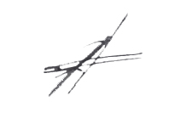
Second author: Go Andrew Purnomo Affiliation: Faculty of Pharmacy, Universitas Sanata Dharma  E-mail address: andrew.purnomo9c23@gmail.com  Phone: 082165708552 | 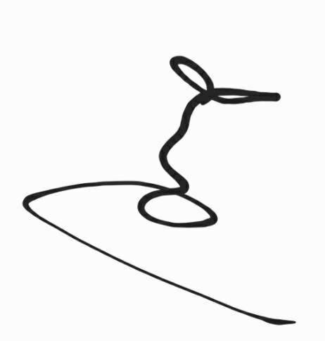

Name and Affiliation | Signature
Third author: Chelsia Devina Maryanto Affiliation: Faculty of Pharmacy, Universitas Sanata Dharma E-mail address: devinachelsia@gmail.com Phone: 082135426252 | 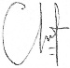
Fourth author: Michael Raharja Gani Affiliation: Faculty of Pharmacy, Universitas Sanata Dharma
E-mail address: mr_gani@usd.ac.id

Phone: 085643207613

