STATEMENT OF ORIGINALITY AND AGREEMENT
I/We hereby certify that my/our manuscript entitled:
Studi Penambatan Molekul dan Prediksi ADMET Senyawa Metabolit Sekunder Tanaman kelor (Moringa oleifera L.) sebagai Inhibitor BACE1 pada penyakit Alzheimer
is an original work of my/our own, except where indicated by referencing and does not involved plagiarism. This manuscript is completely
- has not been published yet in any other publication,
- has not been reviewed by the other publisher,
- has not been sent to the other publisher,
- will not be submitted to the other publishers during the review process,
- the earlier version of the manuscript has been presented in a conference*:

has not been published yet in any other publication,

*) please ignore if never presented.
I/We patiently wait and follow the review process and will not for any reason withdraw the manuscript until final decision; rejected or accepted for publication. If not I/We will be suit and accept any sanction until banned forever from Fitofarmaka: Jurnal Ilmiah Farmasi.

Date: .16/12/2021
Name of authors’ correspondence: Kirka Dwi Apriali
Signature

Name and Affiliation | Signature
First author: Kirka Dwi Apriali  Affiliation: Universitas Padjadjaran  E-mail address: kirka18001@mail.unpad.ac.id  Phone: 0895605326575 | 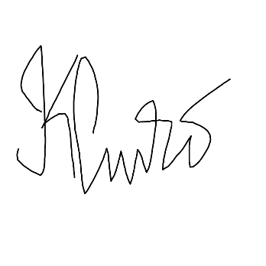
Second author: Efi Triana  Affiliation: Universitas Padjadjaran  E-mail address: efi18001@mail.unpad.ac.id  Phone: 089661107923 | 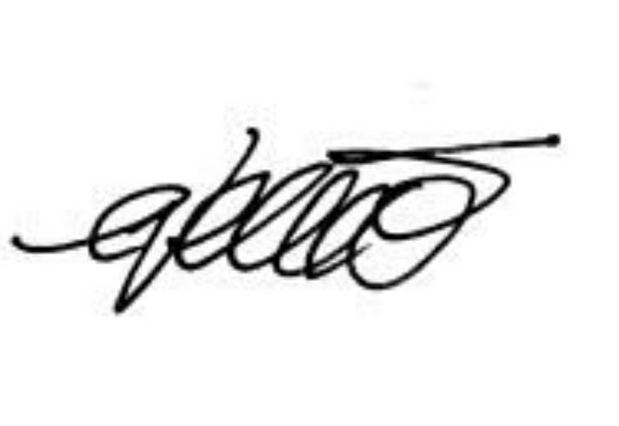

Name and Affiliation | Signature
Second author: Meigita Indah Farhani
Affiliation: Universitas Padjadjaran
E-mail address: Meigita18001@mail.unpad.ac.id
Phone: 082120729590
Second author: Arina Khoirunnisa  Affiliation: Universitas Padjadjaran  E-mail address: Arina18003@mail.unpad.ac.id  Phone: 082269829537 | 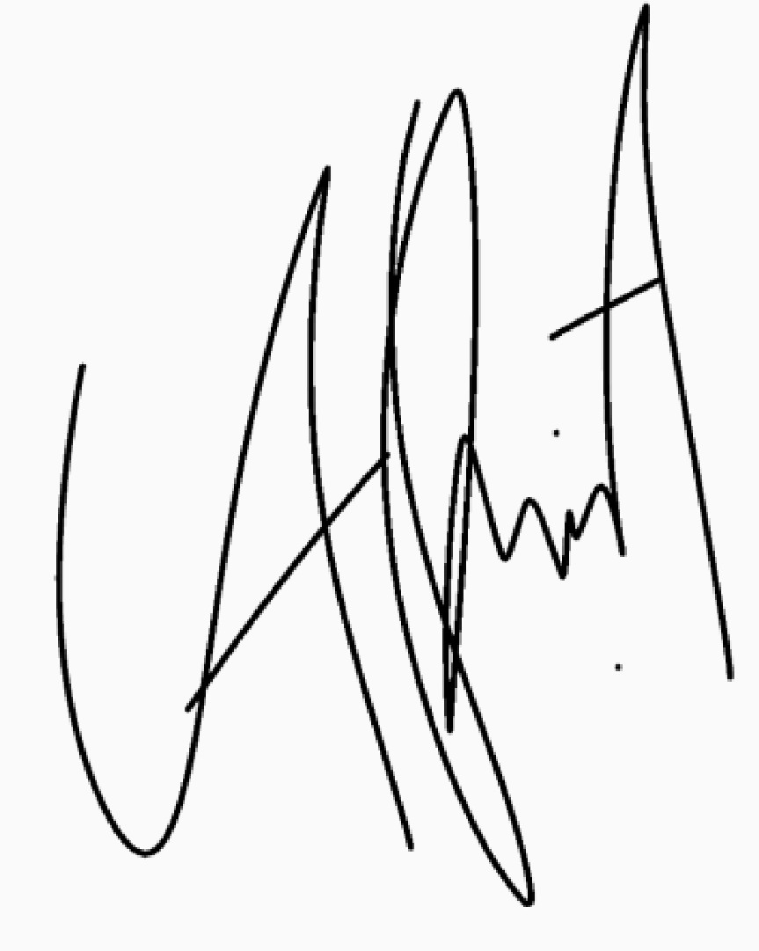
Second author: Yuniar Alfain Nur’aini  Affiliation: Universitas Padjadjaran  E-mail address: yuniar18001@mail.unpad.ac.id  Phone: 082125942028 | 